# Experiment #3 – Regulated Power Supplies

**Last update: 2018A**

**01.10.17**

## ****Objectives****

Acquainting yourself with basic regulated power supplies: discrete voltage linear power regulator, MC7805 Integral power regulator.

Maximum time allotted for this experiment: 6 hours.

## Recommended sources

1. Sedra Adel, S. Kenneth, C. Smith. Microelectronic Circuits, 6th Ed., New York, Oxford. Chap 4.
2. Millman, C., C. Halkias. Integrated Electronics Chap 15, 16.
3. Datasheet: MC7805 , Fairchild Semiconductor.

## Mandatory reading/viewing (files available on our Moodle website)

1. “INFOBIT - How to use the AC transformer”
2. “INFOBIT - DC and AC coupling”
3. Lecture 12 from Prof. Arie Ruzin’s “Analog Circuits” course (Voltage Stabilizers)

## Your personal tour guide

* In your preparatory report, you will analyze the circuits used in the experiment.
* The purpose of the purple text is to give you an overview of what you’re doing – why are you analyzing this circuit? How does it relate to the other circuits? What is the purpose?

## Theoretical background

1. In this experiment you will construct several different power supplies. Their properties derive from the circuits that implement them.
2. Some of the circuits in this experiment use a supply voltage, V+ and V-, which are +15V and -15V, accordingly. These voltages are marked using the standard triangle mark or simply by text (V+, V-). When simulating, please connect grounded dc sources in the right polarity to these nodes in order to get the appropriate voltages – unless stated otherwise (pay attention!).
3. In PSPICE, you may search for components by clicking Place🡪Part🡪Part search, and then typing the name of the part or a partial name with added asterisks. For example, to find BS170, type *BS170* and click “Enter”. Here are some of the components you’ll use and their locations:
   1. Transformer: model XFRM_LIN/CT-SEC in library ANL_MISC.OLB.
   2. Op amp, model LM33/ON in library ON_AMP.OLB.
   3. Transistor BS170/PLP in library BREAKOUT.OLB.
   4. Integral supplier MC7805C in library OPAMP.OLB.
   5. Power transistor MJE340 in library PWRBJT.OLB.
   6. Diode (regular, forward): D1N914 in library EVAL.OLB.

**Preliminary questions and simulations**

* All our power supplies begin by converting the 220V AC outlet voltage to something that is easier to work with – usually 14VRMS. So, the first thing we need to do is use a transformer.

1. On the course website there is a file explaining how to use the transformer. After reading it, answer these simple questions:
   1. Does the transformer have current limiting capability? Explain!
   2. What is the typical output voltage for the transformer with the knob pointing at “4”?
2. The following illustration depicts the transformer you will use in the lab, and the electric circuit that represents it. Note that “14V” and “14V AC” is always measured in RMS:

|  |  |
| --- | --- |
| AC TRANSFORMER  POWER OUTLET  220V RMS  50Hz  **1**  **2**  **3**  **4**  **5** | 0 "14V"  "14V" 0 "14V"  **1**  **2**  **3**  **4**  **5**  **CALL INSTRUCTOR BEFORE POWERING ON!**  0 "14V" |
| Figure 1 |  |

* 1. Explain what is a transformer and how the electric voltage changes from the electrical socket we have in the lab to the transformer’s output. Your answer should refer to the coil’s coupling and use mathematical equations.
  2. Explain the meaning of connecting something to nodes 2 and 3, as opposed to nodes 1 and 3 (see Figure 1).
  3. A common error that may occur is the wrongful assumption that the black-colored output on the transformer means ground. What is the difference between a 0V and “Ground”?
  4. Let’s assume you have a transformer like that in Figure 1.
     1. What would happen if you connect ground to node 5? What are the possible voltages in nodes 4, 5?
     2. What will happen if you connect ground to node 2? What are the possible voltages in nodes 1, 2, 3?
  5. Another option is to wrongfully short circuit two outputs. Explain:
     1. What would happen if we only short circuit nodes 3 and 4?
     2. What would happen if we only short circuit nodes 1 and 2?
* Once you have your 14V AC voltage, you would like to use it to build a DC power supply. How do you convert between AC and DC?
* The first step is to take this AC signal, which is approximately sinusoidal from e.g. -14V to +14V and convert it to a “pulsating” signal, from 0 to +14V. This is achieved using diodes which implement a half- or full-wave rectifier.
* Once you have such a signal, you can use it to charge a capacitor, which would finally deliver a DC voltage – your very first DC power supply!

|  |  |
| --- | --- |
|  |  |
| Figure 2 | |

1. Behold, Figure 2. On the left, you can see the power grid that supplies us with AC voltage. You’ll connect an AC transformer to the electrical socket that transfers a voltage of 220V to 14V, 28V (RMS) of your choosing. When simulating an AC transformer, we may use this implementation – the coupling must be set to 0.07 by double clicking the model. Another way is to use the implementation from the right side of Figure 2.

* Note that in the above PSPICE implementation, we are using 14V amplitude rather than 14V RMS. This is only for convenience in simulation; in the lab you will have 14V RMS.

The next few questions may be familiar to you from “Electronics 1” lab. Calculations are not needed; you should give concise answers.

* 1. Redraw the circuit: **disconnect** the capacitor C and **disconnect** the diode D1.
     1. Is this a half-wave rectifier, a full-wave rectifier, or an (unregulated) DC supply?
     2. Explain what happens in the positive and negative cycle of the input signal.
     3. Draw the input signals AC+, AC- and the output from t=0 until steady state, all three on the same plot. Explain.
  2. Redraw the circuit: **connect** C and **disconnect** D1 and repeat sections ‎3.1.1-‎3.1.3.
  3. Redraw the complete circuit: **connect** C and **connect** D1 and repeat sections ‎3.1.1-‎3.1.3.
  4. During steady state, someone exchanged between AC+ and AC- in section ‎3.3. Explain how would the output look like now.

For the rest of this tutorial, the marking “AC+14” refers to the 14V node and “AC-14” refers to the same but with inverted phase.

* Okay! You now have a measurable DC voltage output, on the capacitor. But, your DC power supply is not perfect..
* When the pulsating signal from the rectifier is lower than the voltage on the capacitor, it may be allowed to discharge through the parallel resistance (R24).
* Effectively, this means that when you reach steady-state, you will not measure a constant DC voltage – there will be a small “ripple” superimposed on it, which most usually does not resemble a sine wave.
* Now that we defined the Ripple, we can define types of accompanying measurements – just by itself or with respect to other quantities.

1. Before you are some typical properties that of the output of DC power supplies. You will measure and use them in the lab. Be advised that some definitions are described differently in different sources; we will now give you the definitions that we will work with in this class. For each definition, answer the following questions:
2. Describe each definition in words (no more than one line per item).
3. Write down a step by step instructions on how to measure each of these properties in the lab. Your answer should refer to (1) the transformer and its operation mode (recall the knob from question ‎1.2), (2) the multimeter/scope and the measuring functions (RMS,VPP), (3) the coupling (AC/DC) and (4) the units of the result.
   1. Ripple: 
   2. Ripple Ratio: 
   3. Ripple Factor: 
   4. Ripple Rejection: 
   5. Line Regulation 
   6. Load Regulation 

*(remember, you cannot measure currents in the lab! How would the formula change?)

* Let’s discuss some circuits that may alleviate the ripple. The circuits that make this ripple smaller, or in general attempt maintain a DC signal with as little ripple as possible, are called “regulators”.
* In the first power supply you designed in section ‎3, we did not add any regulating circuitry; therefore, from now on that circuit (which you will use throughout the experiment) will be termed “unregulated power supply”.

1. Unregulated power supply

Refer to the experimental procedure, section ‎2.



**14VAC RMS**

Figure 3

* 1. Consider the circuit in Figure 3, which illustrates the actual experimental circuit board. Beside the resistor R22, it’s easy to see it is the same circuit as in Figure 2, and it’s easy to understand how the transformer should be connected to the circuit. In the experiment, you will use the rest of the resistors as different loads. Build the circuit in PSPICE and attach a 100Ω load resistor to the output.
  2. Simulate the circuit in the time domain (R22 can be ignored), when the input signal is identical to the one in Figure 2. Attach a print with the input to the rectifier (both signals) and DC output, from t=0 to the steady-state. Calculate the output’s ripple factor.
* Let’s look at our first regulator, the “Discrete voltage regulator”, so named because it is built from discrete components – transistors, resistors and a diode.

Refer to the experimental procedure, section ‎3.

1. Discrete voltage regulator  
   Figure 8 depicts an implementation of a voltage regulator with several functions. We will now analyze this circuit step by step.

* To answer the next questions, **you must review Lecture 12 from Prof. Arie Ruzin’s “Analog Circuits” course** (available on the course website).
* Your answers should be concise; no more than 3 lines per answer.

We will begin with a schematic of a simple voltage regulator; to the left, a general block diagram, and to the right, our implementation with a non-ideal Zener diode:



Figure 4

* 1. Explain how the regulation occurs.
  2. Give three disadvantages of using the Zener implementation.
  3. What would happen if the Zener diode was ideal (rz=0)?

In order to enhance load regulation, we add a transistor in the following configuration:



Figure 5

* 1. What is the significance of the configuration Q5+Q6 in our implementation?
* Hint: Q5+Q6 are in the Darlington configuration. We could in principle replace the two with one Darlington transistor.
  1. Explain how is the transistor advantageous to the load regulation.
  2. Why is there still a problem with line regulation?

To enhance the line regulation property of our regulator, we could use the following (NOTE: the arrows mark the inputs and output of the feedback circuit, and not necessarily directions of currents):



Figure 6

* 1. First, review the implementation of the feedback circuit in “Analog Circuits” Lecture 12. Explain the role of the feedback circuit in line regulation, using the lecture’s implementation.

To understand our implementation, it is easy to treat the feedback circuit R29, P4, R30 and Q8 in particular as a differential amplifier. In steady-state, assuming Q8 is conducting, the regulated output is a certain voltage . Suppose that it suddenly changes to ; then,

1. Q8’s base voltage rises by something proportional to ,
2. Q8’s emitter voltage remains approximately the same,
3. Effectively, Q8’s  rises.
   1. Write down the mathematical expression relating Q8’s  and . What does this relationship imply on the reaction of the feedback circuit to changes from steady-state (as opposed to the mathematical relationship of a resistor, for example)?

* Assume next that the input ripple changes much slower than the response of our feedback loop, or in other words, that the input is constant. Then,
  1. Does  rise or diminish? As a result, does Q8’s collector voltage  rise or diminish?
  2. Keep following the voltage signal from  back to the regulated output. Using this final result, explain how is it possible to adjust the output voltage to a desired value.

What happens if someone loads the output with a resistance  so small, that a tremendous amount of current runs through Q5, possibly burning it? To ameliorate this, we use the combination Rx+Q7 as **overcurrent protection circuitry**:



Figure

* 1. Explain, in the implementation as it is described in Figure 7 (without ), and assuming an input of roughly 18V, Rx=2.4Ω, and output voltage of roughly 10V, why Q7 should never conduct.
  2. What is the relation  between the current through Rx, , and the voltage on Rx, ?
  3. What is the relation  between the collector current through Q7, , and the voltage on BE7, ?
* If you connect a small load at the output, then  would be large enough such that  is high enough to make Q7 conduct. When that happens, it “competes” with the current through Rx according to your answers in ‎6.12-‎6.13. This is how this circuit protects Q5 from burning up due to current overload (or “overcurrent”).
  1. Using your answers in the previous sections, describe (two lines) the path the *majority* of the current takes from the input to the output when Q7 is not-conducting, and when it is conducting.

As a last touch, observe R28 in the complete circuit:



Figure 8

Assume that the input is disconnected completely. All voltages are therefore zero. Because of the feedback loop, the circuit may be bi-stable, which means that in the very first instant that you connect the (high) input, it is not certain whether the circuit will fall into (stable) operation where the diode is conducting, or into (stable) operation where, for example, most of the voltage falls on R27 and the output is still not high enough to bring the Zener diode to break-down (through the base of Q8).

By connecting R28 from the output directly to the diode, we implemented a “bootstrap”. In this way, we assure that the circuit begins operating in our desired state.

* 1. We could implement the bootstrap by connecting R28 to the input rather than the output of the circuit. However, this would be a disadvantage. Why? (Hint: recall that the Zener diode is an implementation of a reference voltage source).
  2. Assume that the input is reconnected, and at t=0+ all voltages are zero. Describe the way current flows from the input to the rest of the circuit and the order in which components turn on.
  3. Roughly estimate the minimal and maximal output voltages of the discrete power supply, assuming 18V input (see experiment section ‎3.2).

1. MC7805 integral regulator

* Let’s look another kind of regulator – the MC7805 “integral” regulator (Figure 9). This is an integrated circuit (hence the name) that not only regulates the input DC voltage with great fidelity, but also has other advantages – such as thermal (overheating) protection.
* This circuit is just an industrial implementation of the block diagram in Figure 6.
* The basic operation of the regulator is to output a 5V signal and up to 1A of current for an input ranging 7V ≤ Vin ≤ 20V.
* To understand how this circuit works, you HAVE to look at the datasheet (available on the course website). In the experiment, we will build and measure two applications for this regulator: the Adjustable Output Regulator (see Figure 11 in the datasheet) and the High Current Voltage Regulator (see Figure 12 in the datasheet).

Refer to the experimental procedure, section ‎4.



Figure 9

* 1. Observe the component data sheet and write down three advantages and features for the MC7805.
  2. Draw a table containing the following component data: Line Regulation, Load Regulation,  
     Ripple Rejection, Output resistance, Short-circuit current, Output voltage. Write the minimal, maximal and typical values for each. See hint below.
* Note: compare the units given for the Load and Line Regulation values in the datasheet to those from section ‎4. You’ll notice that the units don’t match! How do we solve this?? Here are a few hints:
* First thing to notice, is that there is a **typo in the datasheet**. In the first row of Line Regulation on page 2, where it reads “VO = 7V to 25V”, it should actually be “VI = 7V to 25V”.
* Second, you’ll notice in section ‎4.5 that we define Line Regulation to be in units V/V, while the datasheet says mV. What is this number? If you change the DC input from A volts to B volts, then the output would deviate from the designed 5V by C mV.
* For Load Regulation, the datasheet again says “mV”, but in section ‎4.6 the units are V/A.. We follow the same logic: while varying the output current IO, the input deviates from the given test parameter (VI=10V, see row just above the table in the datasheet) by some millivolts.
* Using these hints, and understanding of the meaning of the Load and Line regulations, it should now be obvious how to answer the above question.
  1. Write down the very important Quiescent Current, which you will use for calculations later. This quantity defines the current the device uses for operation under normal conditions.
  2. Draw the schematic of the High Current Voltage Regulator.
  3. Draw the schematic of the Adjustable Output Regulator.
* One of the goals of voltage regulation is not only to have low output ripple, but also to maintain a constant DC voltage in the output. As previously stated, the MC7805 claims to output a 5V signal for almost any load resistance (up to 1A of current).
* In the following sections you will check these two goals by simulation. You will repeat this in actual experiment.

Testing the voltage regulation properties of the MC7805

In order to test the ability of the MC7805 to maintain a 5V DC output for a range of loads, we will employ the following circuitry – the “switched load”:

|  |  |
| --- | --- |
|  |  |
| Figure 10 | |

Figure 10 depicts a switched load (to the right is the equivalent circuit). *We will soon load the integral regulator’s output with it (see Figure 11)*. It is called thus because this load (measured from TP27) changes its resistance according to the controlling signal connected to TP25. We will switch the load “on” (minimum resistance) and “off” (maximum resistance) using a square wave, 0...5V/1KHz/20%D.C. Assume that Q4’s resistance, when conducting, is roughly 0Ω.

* 1. What is the switched load’s resistance and what is the voltage in TP25 when the switched load is “on”? If the MC7805 operates normally, what is the current flowing through the switched load?
  2. Answer the last question again, where this time the switched load is “off”.

The switching signal – the square wave, changes quite abruptly from 0 to 5V. Although a näive approach assumes this is not a problem, practically if we switch the switched load too fast, the electric charge might not react fast enough. For this reason, the capacitor C16 was added – it is a “speed up capacitor”. It stores some of the charge during switching, which is alternately transformed into a high-current pulse into the base of Q4.

Next, we provide simulations of the MC7805 with the switched load attached:

TP18

TP16

0

C14

0.33u

C15

0.1u

MC7805C

IN

1

OUT

2

3

V2

FREQ = 50

VAMPL = 1

VOFF = 10

0

R16

180

R17

10k

C16

330n

Q4

Q2N3055

(or MJE15032)

R18

33

TP28

0

V1

TD = 0

TF = 0

PW = 0.2m

PER = 1m

V1 = 0

TR = 0

V2 = 5

V

V

V

Figure 11

Time

0s

2ms

4ms

6ms

8ms

10ms

12ms

14ms

16ms

18ms

20ms

V(TP28)

V(TP18)

V(TP16)

-5V

0V

5V

10V

15V

(1.5389m,4.9969)

(4.0862m,4.9956)

(6.2050m,10.929)

V(TP28)

V(TP18)

V(TP16)

Figure 12

* 1. In the simulation results (Figure 12), you see three curves. Which is which? Do they fit what you expect from this circuit? Express your answer in two-three lines and prove to the reader that you understand what’s going on. In your answer, use the numbers from the graph.
  2. The current through switched load, assuming the switching is perfectly square-like is approximately given by IL(average) = IL(max) * DutyCycle. Calculate this current from the simulation results.

**Important question**: why do we NEED a switched load in general? Let’s see:

Assume that you have a 20VDC voltage on a “power resistor” (such as R43, R24, R25 and R26 in Figure 3) which can withstand powers of up to **PSAFE** = 5 Watts on average before it excessively heats and damage begins. Take R43 for example.

* Look at the board photo on the website, at resistors R43, R24, R25, and R26. These power resistors are visually different than regular resistors. Also, they read “**5W**” and “**10W**” – these are their power dissipation limits, or “**PSAFE**”, for each resistor.
  1. What is the DC current that runs through R43 under these conditions, ? What is its power dissipation, ?
  2. Using your previous answers (section ‎7.6 and on), what is the maximal duty cycle allowed so the switched load remains undamaged?

Testing the reduction of input to output ripple of the MC7805

An important feature of the 7805 regulator is large attenuation of the ripple between the input and output (i.e., large ripple rejection). In the following section and the experiment we’ll examine this feature. We’ll induce very high ripple (using the wave generator, connected to an RC link) and add a 10V DC to it (in the experiment – this would be the output of your discrete power supply). The ripple and DC voltage will be forced into the 7805 regulator’s input, and we’ll measure the output ripple. To achieve this, we will use the following RC-link:



Figure 13

In the simulation given next, and the actual experiment, you will use this RC-link by connecting it as follows; The ripple we choose here is a sine function of 1.5V/120Hz:



Figure 14

Time

0s

40ms

80ms

120ms

160ms

200ms

V(Vin)

8V

10V

12V

V(Vout)

4.9964V

4.9966V

4.9968V

SEL>>

Figure 15

* 1. Explain how the RC-link helps with adding ripple to the signal. What is the capacitor’s and resistor’s contribution? What would happen if the capacitor was removed (short-circuited)? Give a qualitative explanation.
  2. Approximately, what is the ripple at the regulator’s input? Output? Calculate the ripple rejection; Give two answers, one in dB.
  3. In Figure 14, a DC analysis is given. Note the load is RL=200Ω. Calculate the values of the currents in the three terminals of the MC7805 (marked “1”, “2” and “3”); specifically, why is there a 5mA current out of terminal 3? Is the circuit operating as expected? Use the datasheet for this answer.
* By now you are supposed to understand perfectly the properties and operation of the MC7805 “integral” voltage regulator. Now, let’s see two applications that use this component; you will actually build these in the experiment!

Refer to the experimental procedure, sections ‎4.13 and ‎4.18.

* 1. Application #1: High Current Voltage Regulator

This implementation allows increasing the load current while keeping the regulator working with a low, steady current. It is done by steering excess current directly to the output rather than into the integrated regulator, effectively employing a current limiting circuitry (*compare this to the current limiting circuitry in the discrete regulator!*).

Reminder: refer to Figure 12 in the datasheet for this circuit.

0

Ry

Q2

MJE2955

0

INTEGRATED

REGULATOR

DISCRETE

POWER SUPPLY

0

RL

200

0

Figure 16

* In the experiment, you will perform a couple of measurements on this circuit, where the value of Ry is not known – you will have to find it yourself.
* You can measure the voltage on it, but you can’t directly measure the current through it! What you will do, is perform one measurement where Q2 is definitely off (not conducting), and use this “extra” data to deduce the value of Ry.
  + 1. Assume that Ry=7.5Ω and that Q2 is on the verge of conductance (VBE,ON=0.5V). Using the Max. Quiescent Current (section ‎7.3), what is the minimal load resistance  you can attach, and Q2 would still not conduct?
    2. Review sections ‎4.13-‎4.17 in the experiment. Using your previous answer, write down the equations and explain how would you calculate the value of Ry.
    3. Assume the discrete power supply outputs a 10V DC signal, , and explain how the circuit works when Q2 is open. Calculate the currents and give a concise explanation on how this circuit can increase the current through the load.
    4. In one line, what is Ry used for? (Hint: it is similar to Rx).
  1. Application #2: Adjustable Output Regulator

The following Figure 17 is part of the circuit board you will have in the experiment. Much like in the *discrete regulator*, here we also employ feedback to control the output DC voltage and be able to regulate it (to choose its value). *You should understand how this feedback loop works, according to your analysis of the similar circuitry in the discrete regulator!*

Reminder: refer to Figure 11 in the datasheet for this circuit.



Figure 17

* Notice **R12**: this resistor doesn’t exist in the datasheet schematic. It is added for practical reasons: to prevent excess current from flowing into the output of the op amp.
* Also note **R15**: this acts as your *load resistor* in the experiment.
  + 1. In this experiment you’ll be required to connect the op amp according to the datasheet. Refer back to your drawing in section ‎7.5, add a drawing of the MC7805 (according to the datasheet) and mark in a different color the connection you will have to make on the circuit board in order to build this application. NOTE: draw and assume that the input to the MC7805 is a 18V DC voltage supply.
    2. According to the datasheet, what is the range of DC output voltage possible with this application? You should understand that beyond this range, the manufacturer doesn’t say what will happen – but we can safely assume it will not perform optimally (or, at all as expected!).
* Okay, enough about regulators.
* In the beginning of this preparatory report, you learned how to build an unregulated DC voltage supply using a half-wave or full-wave rectifier and a capacitor. In many applications, such as in your PC, it is required to convert an AC input into several regulated DC voltages. Instead of using a simple rectifier and a capacitor, we will now use a different implementation of a power supply – which uses a diode bridge to rectify the AC signal and a very large capacitor to create the steady DC voltage. The different DC outputs are implemented using additional diodes.
* This circuit will also implement the 34V source needed for Application #2 of the MC7805.

1. Multi-output DC power supply  
   Observe the following diagram, which is copied from the circuit board; note the “+28VAC” and “-28VAC” inputs – these are of course only momentarily “+” and “–“, since half a cycle later they reverse signs.



**28VAC RMS**

Figure 18

The two input terminals to this circuit are connected directly to the AC transformer, just like in Figure 2 (but without the ground terminal). Give a detailed explanation of how the circuit operates by using the following sections (simulation not needed):

* 1. D2-D3-D4-D5 diode bridge (Hint: you’ve seen this configuration in “Electronics 1” lab):
     1. Explain which diodes conduct and which are off during the positive and negative halves of the input signal.
     2. Draw on one plot both the input signals TP34, TP33 (what are the signals in the transformer’s output?), and mark on every half-cycle which diode is conducting, to prove the previous section.
  2. What are the advantages of using a diode bridge rather than a full-wave rectifier such as the one you analyzed in Figure 2?
  3. Show in calculations how does one reach approximately 34V in the top-most output in steady-state. Note that the input is 28VAC RMS. Assume also that every diode breaks down at 0.8V and the Zener diode breaks down (reverse breakdown) at 22V.

**\* The preparatory report is not finished! There are more questions below! \***

Self-quiz and preparation for actual measurements

You’re almost finished with the preparatory report. Don’t stop now..

* In the experiment you’ll be “thrown in the water”, so you must know exactly what’s going on and what you should do at all times. By answering these questions correctly, you’ll be assured that you can perform the required tasks in the lab.
* **Both you and your partner must separately pass the online “circuit connection quiz” before you are allowed to begin the experiment!**
  1. Some circuit building steps during the experiment  
     As you progress through the experiment, overall, you may view your circuits as being modular. For each of these sections, review the experimental procedure and your answers to the preparatory report so far – we recommend that you write down instructions for each section explaining how to build these circuits. Refrain from mentioning TP numbers!
     1. In section ‎2, you will build the unregulated power supply:

0

UNREGULATED

POWER SUPPLY

50Hz

220V RMS

POWER OUTLET

TRANSFORMER

UNREGULATED POWER SUPPLY

AC

RECTIFIER

CIRCUIT

* + 1. In section ‎3, you will add the discrete voltage regulator to it to form a regulated power supply:

POWER SUPPLY

UNREGULATED

REGULATOR

DISCRETE

DISCRETE POWER SUPPLY

0

* + 1. In section ‎4 you will connect the integral regulator and the switched load to your unregulated power supply. Your final circuit now looks like this:

INTEGRATED

REGULATOR

DISCRETE

POWER SUPPLY

SWITCHED

0

LOAD

INTEGRATED POWER SUPPLY

* + 1. In the last few subsections of the experiment, sections ‎4.13-‎4.23, you will build and analyze two applications of the integral regulator MC7805. You’ve already addressed these in sections ‎7.15 and ‎7.16.
  1. Output resistance measurement

In the experiment, section ‎2.21, you are asked to measure the output resistance of the unregulated power supply. There, your circuit schematically looks like this:

|  |  |
| --- | --- |
| UNREGULATED  POWER SUPPLY  0  RL  51 |  |
| Figure 19 | Figure 20 |

The load RL and the output resistance of the power supply ROut are a part of a voltage divider between V­Out (unloaded) and V­Out (loaded with RL). Using the schematic in Figure 20, give a formula for the calculation of ROut. Explain each of the quantities (VA,VB,RA,RB).

* 1. Line regulation measurement

In the experiment, section ‎3.3, you are asked to measure the line regulation of the discrete regulator supply. Following section ‎4 in the preparatory report, you must measure ∆Vo (the change in the discrete regulator’s output) versus ∆VI (the change in the discrete regulator’s input); your measurements should have 3 significant digits.  
Since you’ll measure differences, you will need to decide on a reference. In this case, it will be the middle setting on the AC transformer (SW=3=0%). The other measurements would be taken by changing the transformer’s knob – this is the only way you have to change the input DC voltage to the discrete regulator! Also, since high-accuracy is required, use the multimeter.  
Lastly, you will fill the given table and calculate line regulation for each difference from the reference; the largest result would be defined as the regulator’s line regulation. It is customary to write the result in percentages (out of 100%).

Let’s see if you got it: suppose for a regulator’s input of 14.000V, you measure its output to be 10.000V. A second measurement of 13.510V in the input matches with 9.912V at the output. Calculate line regulation for this case.

* 1. Load regulation measurement

In the experiment, section ‎3.5, you are asked to measure the load regulation of the discrete regulator supply. Following section ‎4 in the preparatory report, you must measure ∆VL (the change in the discrete regulator’s output for a given load) versus ∆IL (the change in the discrete regulator’s output current through the load); your measurements should have 3 significant digits.

We do not allow measuring currents directly in the lab, which is why you have to tweak this formula just a bit.

Otherwise, the measurement is similar in principle to the line regulation measurements. Your reference will be the 1KΩ measurement. It is customary to express the result as the ratio “1:XX V/A”.

Let’s see if you got it: suppose for a regulator’s input of 14.000V, you measure its output to be 12.000V for a 200Ω resistance. A second measurement of 14.000V in the input matches with 12.150V at the output for a resistance 1KΩ. Calculate load regulation for this case.

# Experimental procedure

|  |  |  |  |
| --- | --- | --- | --- |
| 19 | B56-08 | 308177815 | Alon moses |
| 204301758 | Ido debi |
| **Booth number** | **Board number** | **Student IDs** | **Your names** |

Reminder:

1. **All the answers for the practical and theoretical questions shall be written down in this document, during lab hours only.**
2. **Save this file as “report3_XXX_YYY” when XXX, YYY are your students ID’s. Please save this document right now as to avoid any future inconvenience.**
3. **At the end of this lab you must upload this file under the right assignment to the course site and click “hand in assignment”:**

**• If you have yet to complete this experiment in its entirety, please upload the file under the “Progress report” assignment.**

**• If you had completed this experiment and answered all of the questions, please upload the file under the “Post lab (Final)” assignment.**

1. **You cannot “fix” sections that have been answered without a special approval from your lab instructors.**
2. **You should not attempt to upload or send the assignments from your home or after/before lab hours.**
3. *Before we begin..*
   1. **Important safety instructions – MANDATORY READING:**
      * 1. The transformer in this experiment uses currents greater than the ones you’ve gotten used to, putting the components on the board in danger of overheating and burning.
        2. These components include all the power resistors in Figure 3, power transistors in Figure 10 and the MC7805 in Figure 9.
        3. The power resistors, for example, are meant to withstand a power of no more than 5-10W, but nevertheless, sometimes the circuits you’ll construct can dissipate more than 10W on the load – therefore, it is very important to not leave the system running and operating for more than the minimal time required for your measurement. **The measurements should not last more than a few seconds.**
        4. In addition, wrongfully connected nodes and terminals may cause fire, damage to the board and even injury to yourselves. Before any change of a connection is made you must turn off the supply voltages to the board and the transformer. **Where mentioned in the text OR diagram, you must call the lab instructor for his approval prior to turning on the transformer!**
        5. Because of past incidents of students not heeding these warnings and burning boards, repeated cases of components burning in your station may lead to you being ordered to cease all activity in the lab and fail the experiment.
   2. Safety reminder

The board contains many metallic parts, some of which with relatively **high voltage** and the ability to conduct **high current**. This means you may very easily burn things or in some extreme cases even get electrocuted.

**NEVER “throw” wires around on the board, or leave a wire unattached!**

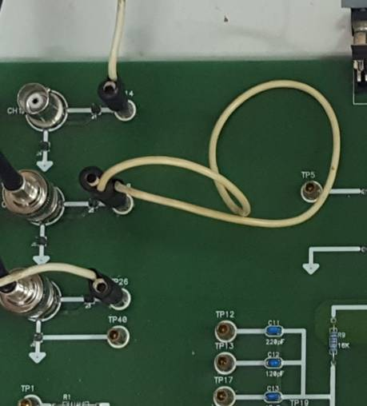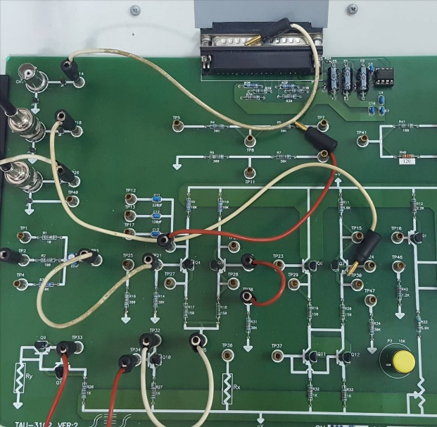

Figure

1. **Unregulated power supply**

Building the circuit (Refer to the preliminary report, sections ‎3-‎5)

* We will actually begin by building a full-wave rectifier, and later make it into the infamous unregulated voltage supply.
  1. Make sure the transformer and station base are turned off. Connect the full-wave rectifier **only** according to the preliminary report, similarly to your answers in sections ‎3-‎3.4.
  2. Set the transformer to SW3. Connect the middle terminal of the transformer (terminal 2 in Figure 1) to R22, and the other end of R22 to the ground (NOTE: the marking “GNDAC” next to TP41 should be ignored; it is not connected to the ground).
  3. Connect one of the AC inputs to the scope’s CH2 and the rectified output to CH1.
  4. Complete the transformer connections according to this diagram:

0 "14V"

"14V" 0 "14V"

**TP39**

**TP41**

**TP40**

**X**

**X**

**CALL INSTRUCTOR BEFORE POWERING ON!**

0 "14V"

Figure 22

* Pay close attention to the transformer’s illustration in Figure 22; you’ll come across it quite often in this experiment. It indicates two important things:  
  (a) Which TP nodes connects to which output (note that some of them are disconnected)  
  (b) You **must call the lab instructor before powering on the transformer!**
  1. Adjust the view appropriately and measure these signals in DC coupling.
* Note that even in the highest scale, the AC input cannot be fully visible on the scope in the current setting, since the highest scale for the scope is 5V/div.
  1. Add measurements of min, max, and frequency of the rectified signal, and a measurement of the frequency of the AC input (total of 4 measurements). Note what scales you’ve chosen (make sure the signal extends the full height of the screen). Attach a print.

*Print: AC input and rectified signals of the full-wave rectifier*

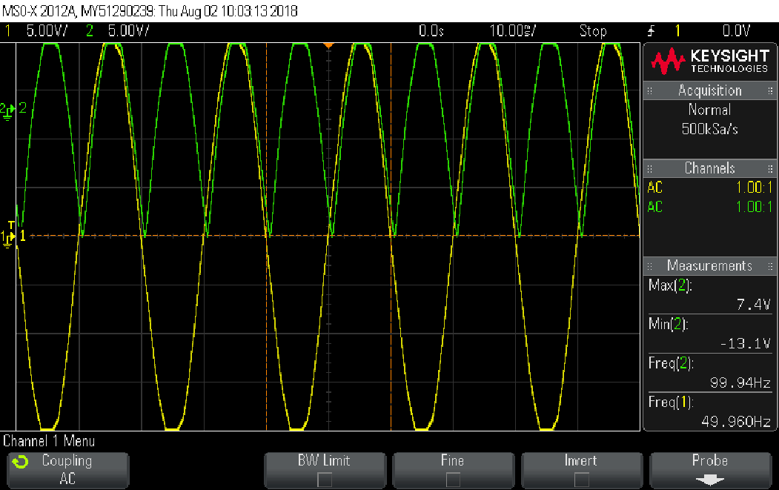

* 1. Save the scope’s view (using Capture Waveform) – you will print these signals again with additional measurements in section ‎2.11. Note that you must keep the same scales. Then, disconnect CH2.
  2. **Turn the transformer OFF.**
  3. Complete the required connections to make this full-wave rectifier into an unregulated power supply, similarly to the preliminary report, sections ‎3.3 and ‎5, and load your power supply with a 100Ω resistor. Schematically, you now have this:

0

UNREGULATED

POWER SUPPLY

RL

100

Figure 23

* 1. To make sure you are following the experiment correctly, BEFORE continuing, answer these questions, one line each:

|  |
| --- |
| **Explain how the unregulated power supply operates.** |
| חיברנו בנוסף את הקבל כך שנקבל במוצא מתח מיושר עם RIPPLE. בזמן ששני הסיגנלים לא בערכם המקסימלי, הקבל מתפרק, לכן נוצרת ירידה של מתח הDC במוצא. |
| **What kind of signal is inputted? What kind of signal is outputted?** |
| נכנס מתח AC ויוצא מתח DC יחד עם RIPPLE בעקבות פריקת הקבל. |
| **Think: What coupling should you use to measure the output?** |
| DC |
| **What coupling should you use to measure the output’s ripple?** |
| AC |

* You’ve completed the construction of your first power supply (Mazal Tov!)
  1. Measure the power supply’s output with CH1, adding measurements of its RMS, VPP and frequency (total of 3 measurements). Attach a print that includes the rectifier’s output that you captured earlier (in section ‎2.7), in the same scales as before.

*Print: Comparison of the rectifier and unregulated power supply outputs.*

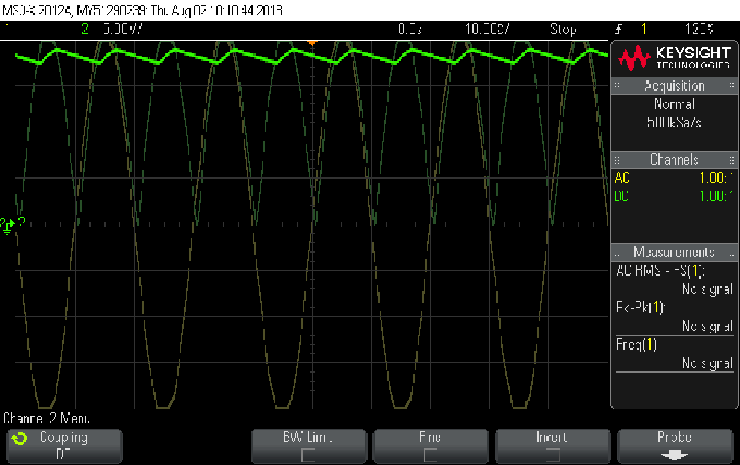

* 1. **Turn the transformer OFF**.

Power supply measurements

* Let’s analyze your unregulated power supply. We’ll make a couple of measurements:  
  (a) the capacitor’s charging current,  
  (b) the supply’s ripple in steady-state,  
  (c) the capacitor’s discharge time, and  
  (d) the power supply’s output resistance.

*Measuring the capacitor’s charging current:*

* 1. Claim: the current through R22 is approximately equal to the current through the capacitor. Look at the circuit schematics (use Figure 2, and think how the current flows there), and briefly explain; also explain what could theoretically be changed in the circuit to make the current through R22 identical to that through the capacitor.

|  |
| --- |
| ניתן לראות כי הצומת שמחוברת לאדמה משותפת לR22 ולc19. לכן הזרם שמגיע מהצד השמאלי של המעגל שווה לזרם שמגיע מהצד הימני. בזמן הפריקה של הקבל זהו הזרם היחידי מהצד הימני. לכן זרמים אלו שווים. |
|  |
|  |

* 1. CH1 still measures the DC output; use CH2 to measure the voltage drop on R22. Since we do not allow measuring currents directly in this lab, you will instead measure the voltage drop on R22 and deduce the current through it using Ohm’s law.
* The goal of the next few steps is to measure the DC output from power on (t=0) until the circuit reaches steady-state. You’ll get a very nice print out in the end!
  + 1. On the scope’s screen, set the GND (marked by a small ground arrow on the left-most edge of the screen) of CH1 and CH2 to coincide. Set CH1 to **5V/cm** and CH2 to **2V/cm**. Set the time axis’ scale to **400ms/cm**.
* Reminder: by pushing the scale knob, you can alter the sensitivity from *fine* to *coarse*.
  + 1. Observe the horizontal line scanning along the screen. Once the time marker reaches the start of the screen, turn transformer on; when the scan reaches the end of the screen, click Run/Stop to stop the freeze the image. **Turn the transformer OFF.**
    2. Center the image and lower the time axis, to about **20ms/cm**, so you can see both the current through R22 and the unregulated power supply reaching steady state voltage. Measure the *peak* charge current on screen and attach a print.

*Print: capacitor voltage and charging current with measurement*

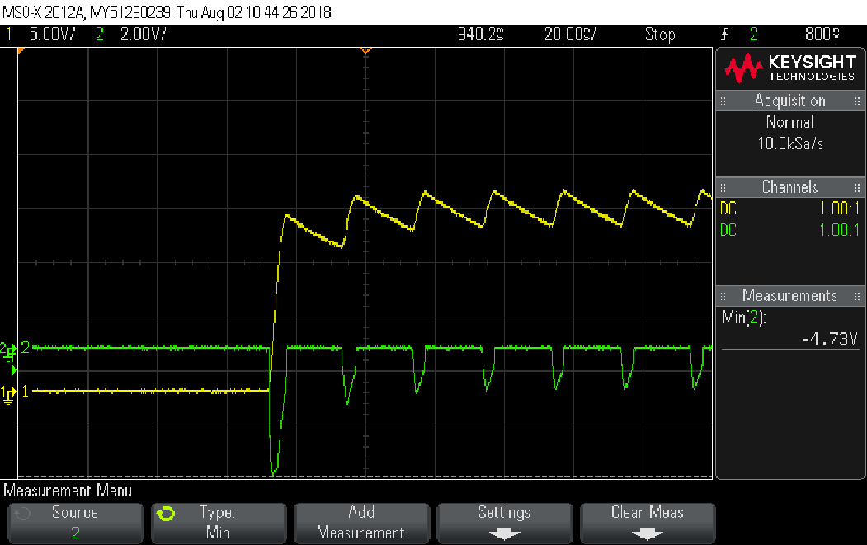

*Measuring the supply’s ripple in steady-state:*

* 1. Change the time axis to 4ms/cm. Set CH1 and CH2’s scale to 500mV/cm. Turn the transformer on and select the appropriate coupling for CH1 so you can see the capacitor’s ripple on screen and also its steady state current.
  2. Add a VPP and frequency measurement for the ripple (total of 2 measurements). Attach a print. **Turn the transformer OFF.**

*Print: Unregulated power supply’s ripple and the capacitor's steady state current*

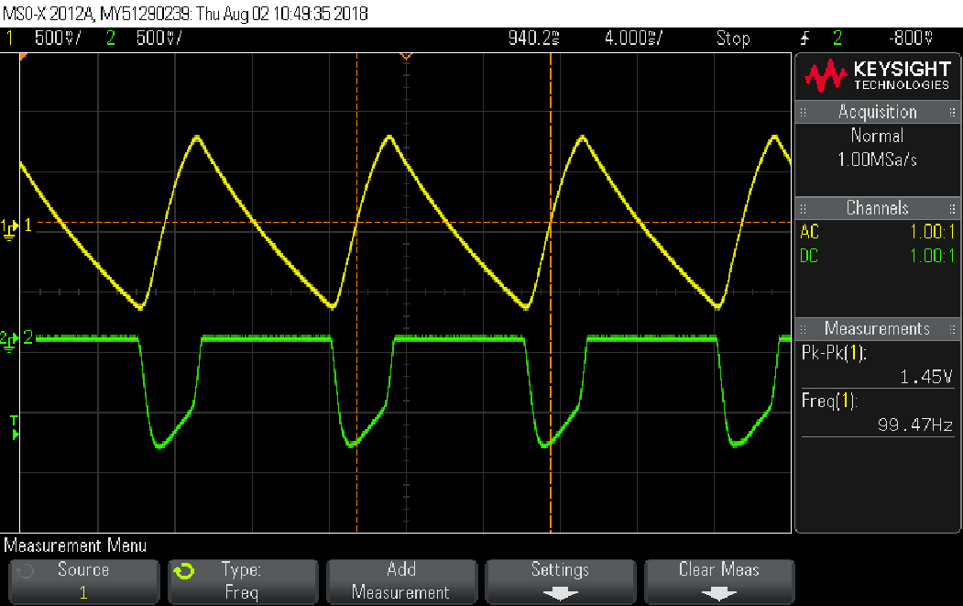

*Measuring the capacitor’s discharge time:*

* 1. Turn off CH2 and leave CH1 as follows: DC coupling, 5V/cm, 0.4sec/cm. Turn the transformer on and when the scan reaches the middle of the screen, turn off the transformer and make sure you can see the voltage discharge. When it reaches the end of the screen, freeze the image. **Turn the transformer OFF.**
  2. On screen, measure the time (in seconds) for the capacitor to discharge to 37% of its starting value. Attach a print.

*Print: capacitor’s discharge time*

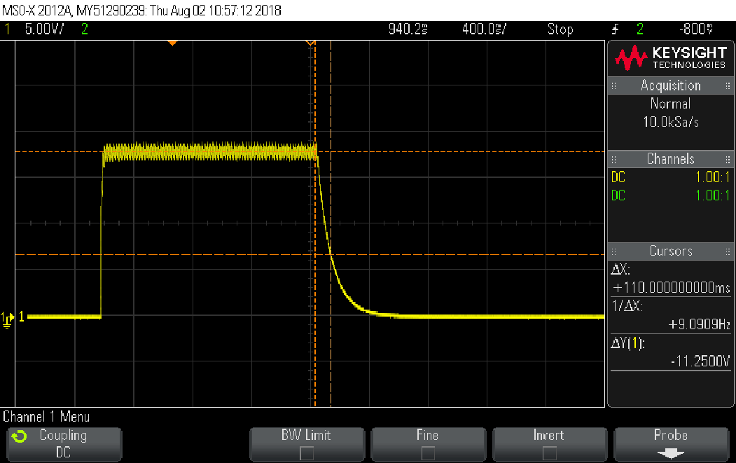

* 1. Using the circuit’s parameters, calculate the time constant for this simple RC circuit, and compare the result with your measurement. Explain any differences.

|  |
| --- |
| R25*C19=0.1sec |
|  |
|  |

* 1. Turn off the transformer and **unplug the 1Ω load** from the circuit, by removing the transformer’s terminal from R22 and connecting it to the GND in TP47.  
     **From now on you will not make any use of the R22 resistor.**

**Ignoring this instruction may cause R22 to overheat and burn.**

*Measuring the unregulated power supply output’s resistance:*

* NOTE: Make sure the scope and multimeter are not connected to the same node!
  1. Disconnect the 100Ω load resistance. Measure the output resistance according to the preliminary report. Use RL=R24=51Ω and the multimeter. Note which coupling you use.

|  |  |
| --- | --- |
| **Measurements:** | |
| 20V | V­Out (unloaded) |
| 18V | V­Out (loaded with RL) |
|  |  |
| **Result:** | |
| ((20/18)-1)*51=5.6ohm | RO |

* 1. What can you say about your results? Does it fit your expectations from a power supply?

|  |
| --- |
| ניתן לראות כי קיבלנו נגד מוצא קטן כפי שאנו מצפים ממקור הספק כך שלא מתבזבז הרבה הספק על הנגד. |
|  |

* 1. Make sure the transformer is turned off.
* Great! You’ve analyzed your power supply. Now, let’s add some functionality to it – namely, regulation and the ability to adjust the DC voltage of your supply.

1. **Discrete power regulator**

Building the circuit (Refer to the preliminary report, section ‎6)

Recall Figure 8 from the preliminary report. NOTE: resistor R27 was changed to 3.3KΩ to moderate component heating. This change isn’t substantial to the operation of the circuit. Still, pay attention – Q5 heats rapidly; you must turn off the transformer between measurements!

* 1. Regulate your unregulated power supply by connecting the discrete regulator. If this is the beginning of the lab session and you’re connecting everything from scratch, remember to build your unregulated power supply **without R22**, and to **get the lab instructor’s approval before turning on the transformer!** Your completed circuit should follow this schematic:

POWER SUPPLY

UNREGULATED

REGULATOR

DISCRETE

DISCRETE POWER SUPPLY

0

Figure 24

* You’ve built a new power supply. Henceforth it shall be known as “discrete power supply”!
  1. Your power supply has adjustable output voltage. Measure the input to the discrete regulator (not the whole power supply), and adjust the output to the lower and upper limit of the whole power supply’s output voltage. Compare with the preliminary report’s calculations (section ‎6.17).

|  |  |
| --- | --- |
| **Measurements:** | |
| 19.6V | V­in (discrete regulator) |
| 7.4V | V­out, low (power supply) |
| 12.94 | V­out, high (power supply) |
|  | |
| **How different are these measurements from your preliminary calculations?** | |
| בדוח המכין קיבלנו טווח של 8V-13V. ניתן לראות התאמה למכין. | |

* Let’s see how this discrete power supply of yours fares, by measuring and calculating some of the properties discussed in the preliminary report!
* You will now measure the discrete regulator’s:  
  (a) line regulation, and  
  (b) load regulation.

Power supply measurements

*Measuring line regulation:*

* 1. Load your discrete power supply with a 200Ω resistance. Set the output voltage to about 10V and fill the table below. Highlight the correct value that defines the regulator’s overall line regulation in yellow, according to the definitions in the preliminary report:
* Shut down the transformer between measurements!

|  |  |  |  |  |
| --- | --- | --- | --- | --- |
| Line Regulation | Vo | Vi | SW | LINE % CHANGE |
| 1.73% | 10.1 | 20.71 | 5 | +10% |
| 1.79% | 10.08 | 19.52 | 4 | +5% |
|  | 10.06 | 18.4 | 3 | 0 |
| 3.09% | 10.03 | 17.43 | 2 | -5% |
| 2.94% | 10.01 | 16.7 | 1 | -10% |

*Measuring load regulation:*

* Make sure the scope and multimeter are not connected to the same node! This is why in this part we made sure that TP53 isn’t connected to any voltage source, and we unplugged the multimeter before continuing with further connections.
* **Pay attention:** P5 is a sensitive potentiometer and was not designed to withstand large currents, therefore the next measurements should be done swiftly, with P5 being connected only while measuring, being unplugged immediately after the measurement and the transformer being turned off.
* **Also important:** throughout this entire experiment, the components, like you’ve noticed, heat up. The rising temperature may cause a measurement to slowly change and not settle on a specific value. When this happens, just take the value you see after a few seconds; do not wait for a stable result with the transformer on, **it will not happen!**.
  1. For this measurement we would like you to use a 1KΩ resistor.
     1. Make sure nothing is connected to TP53. If there is, disconnect it now.
     2. Use the multimeter to measure the resistance (“Ω2”) at node TP53.
     3. Change the potentiometer until you measure 1KΩ (±5%).
     4. Press “DCV” on the multimeter, and disconnect it from the circuit. **\*this step protects the multimeter’s circuitry, do not skip it!\***
  2. Make sure the your discrete power supply is loaded with a 200Ω resistance. Set the transformer’s knob to SW=3=0%. Set the output voltage to about 12V±0.2V and fill the left side of the table below. Remember to turn off the transformer after every measurement.
* Shut down the transformer between measurements!

|  |  |  |  |  |  |  |  |  |
| --- | --- | --- | --- | --- | --- | --- | --- | --- |
| Load Regulation | PQ5(W) | PRL/PSAFE (%) | PRL(W) |  | IRL(mA) | Vo[V] | Vi[V] | RL |
|  | 17.42167 | 115.78% | 0.14472 |  | 12 | 12.06 | 19.83 | 1kΩ |
| -1.38298 | 16.85521 | 14.15% | 0.707705 |  | 59 | 11.995 | 19.25 | 200Ω |
| -0.64875 | 16.39625 | 14.38% | 1.437601 |  | 119.9 | 11.99 | 18.79 | 100Ω |
| -0.40541 | 15.83042 | 28.01% | 2.80098 |  | 234 | 11.97 | 18.22 | 51Ω |

* 1. Continue filling the right side of the table by calculating the load regulation for each load (relative to the 1kΩ resistance), the power dissipation on the load resistor, PRL, and on Q5, PQ5. *Do NOT measure TP49*; you might have to make some assumptions to calculate these quantities. If you require the value of Rx, then use 2.4Ω, and assume VRX~0.5V. Highlight the correct value that defines the regulator’s overall load regulation in yellow, according to the preliminary report.
  2. Also, in the column PRL/PSAFE, write down the division between the load power dissipation and the power dissipation rating of the resistor (assume PSAFE for the 1kΩ is 0.125W). Are any of the resistors in danger of being damaged?

|  |
| --- |
| **Relevant equations you’ve used to calculate the values, assumptions and justifications:** |
| (Vo-Vi-0.5)* (VRx/Rx) |
| Vo*IRL |
|  |
| **Are any of the resistors in danger of being damaged?** |
| כן, מדדנו הספק גדול מההספק PSAFE על הנגד 1K. לכן הוא בסכנה. |
|  |

* 1. Turn the transformer OFF and disconnect the load resistor.

Testing the current protection mechanism

* **Be advised!** In this section Q5 and the 24Ω resistor may overheat and damage. You must read the entire section before you start measuring; do not connect the 24Ω load (R34, TP52) for an extended period of time, but only “touch” the TP52 node with the wire, click “Run/Stop” and then “release” the wire. **The entire measurement should not be more than 5-10 seconds!**
  1. Using the scope: let’s see if the circuit operates correctly. Make sure the power supply’s output is not loaded, and that the voltage is set to about 12V. Change the load to R53=24Ω (TP52); if the current protection kicks in, you will see a sharp voltage drop at the output (to approximately 6-7V). Write down this value. Disconnect the load and make sure that the power supply goes back to its normal state.

|  |  |
| --- | --- |
| 5.9V | Vout |

* As you may remember from “Electronics 1” and from your own theoretical knowledge, you may never use two measuring devices together (E.G. the scope and the multimeter) at the same spot at the same time. That is because they are not ideal, and their input resistances may affect each other, giving you a possibly, entirely invalid result. You may be tempted to try such a thing in order to save time – **DON’T!**
  1. Finding the value of Rx: set the regulator’s output voltage to its maximum value, then reconnect the 24Ω load, and use the multimeter to measure the regulator’s input and output and TP49, each in turn (make sure the transformer is only on for a short period of time). Turn off the transformer and disconnect the load.  
       
     Calculate the voltage falling on Rx, and assuming  calculate Rx; compare to the nearest value of the three: 2.2Ω, 2.4Ω, 2.7Ω.

|  |  |  |  |  |
| --- | --- | --- | --- | --- |
| Coupling? | VTP49 | | V­­­out | V­­­in |
| DC | 6.61V | | 5.93V | 18.56V |
| Voltage on Rx: | | |Vout-Vtp49|=0.68V | | |
| Current through Rx: | | Vout/RL=0.247A | | |
| Value of Rx: | | IRx*VRx=0.17ohm | | |

* 1. Measuring the ripple ratio: disconnect the 24Ω load and attach RL=100Ω to the output. Set the output voltage to 12V. What is the current running through the load in this case? Compare this to the  value from the previous section.

|  |
| --- |
| **Answer:** |
| vout/RL= 12V/100ohm=0.12A |
| תוצאה זו הגיונית מכיוון שההגנה על הזרם דרך נגד ה24ohm גרמה למתח עליו לקטון פי 2, ומכיוון שהוא קטן פי 4 מהנגד של ה100ohm נקבל כי הזרם דרך נגד ה100ohm קטן פי 2 מהזרם על נגד ה24ohm. |

* In the next section, we will use the ripples’ different frequencies (input vs. output) to practice using the scope’s Trigger option.
  + 1. Present the discrete regulator’s input ripple (*not* the discrete supply’s input) on CH1 with 1V/cm scale, and the output ripple on CH2 with 0.5V/cm scale. Use the correct coupling for this measurement. Attach a print with VPP and frequency measurements (total of 4 measurements). Make sure that the trigger is set for Source1 and the signal is “frozen” using the Trigger knob and setting the Trigger level correctly.
* Click Trigger🡪Source and use the correct knob to move the level of the trigger, so the signal freezes. Be advised: clicking on Auto-Scale may change to source of the trigger to source1 automatically.
  + 1. Attach a second print of the two ripple signals (total of 4 measurements). This time make sure that the trigger is set to Source2 and the signal is “frozen”.
    2. Calculate the ripple ratio according to the preliminary report.
    3. **Turn the transformer off after measuring.**

*Print: input and output ripple with trigger on Source1*

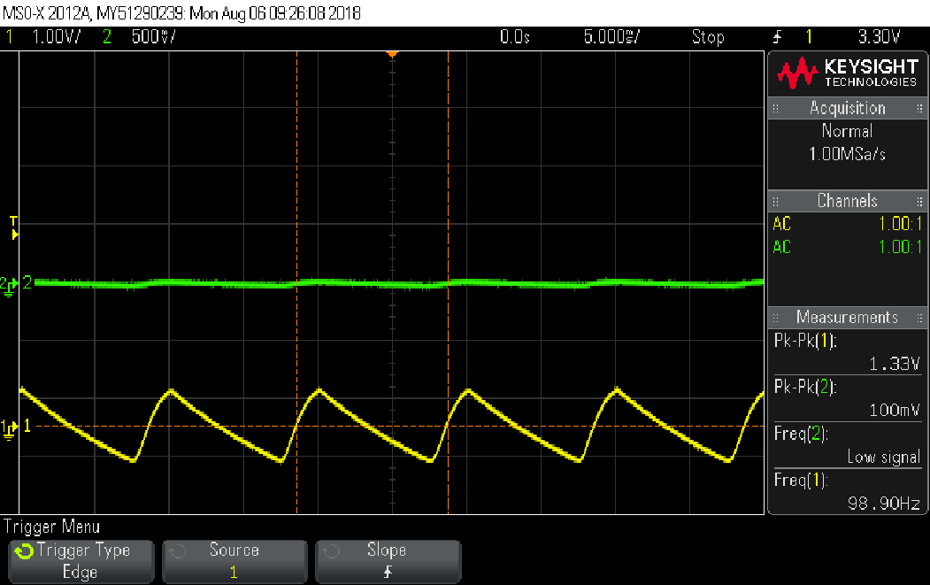

*Print: input and output ripple with trigger on Source2*

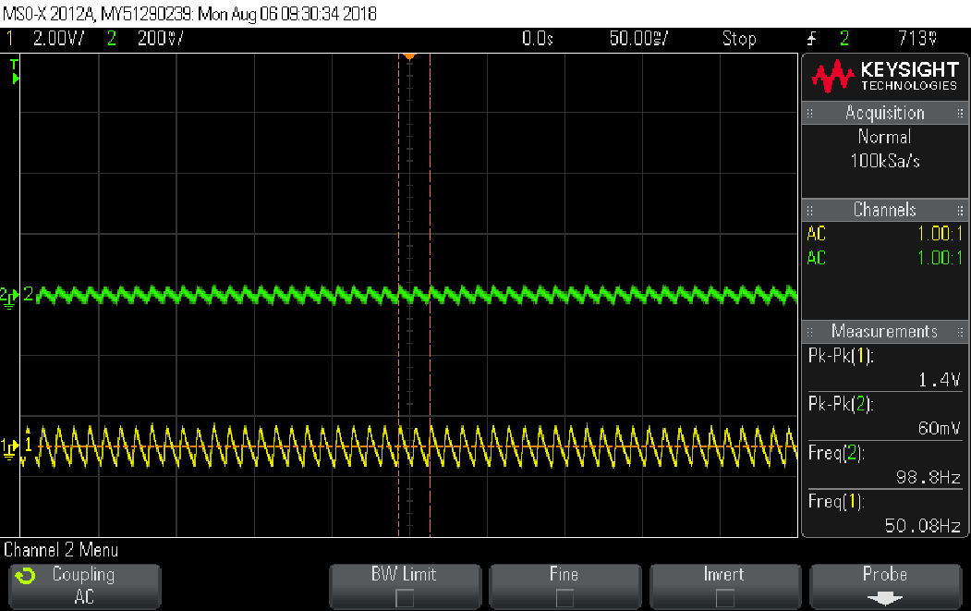

|  |
| --- |
| **Ripple ratio:** |
| 60mv/1.33v= 45% |

* 1. Disconnect the load.

* 1. In the next section of this experiment you will build and use the MC7805 integrated-circuit voltage regulator. Compare your measurements of the discrete voltage regulator’s load regulation, line regulation and approximate current limit (“short circuit current”) to the corresponding values of the MC7805 from its datasheet (section ‎7.2 in the preliminary report). Quote the values from the preliminary report here when you make the comparison.

|  |
| --- |
| load regulation - בניסוי קיבלנו: 0.4 ובדפי היצרן נתון: 0.669. |
| line regulation – בניסוי קיבלנו: 0.017 ובדפי היצרן נתון: 0.222. |
| -short circuit בניסוי קיבלנו: 0.247A ובדפי היצרן נתון: 0.23A |
|  |
|  |

1. **MC7805 integral regulator**

Building the circuit

* 1. Make sure the transformer is OFF.
  2. Use the preliminary report (sections ‎7, ‎7.8) to build the “integrated power supply”. If this is the beginning of the lab session and you’re connecting everything from scratch, remember to build your unregulated power supply **without R22**, and to **get the lab instructor’s approval before turning on the transformer!** Your complete circuit should follow this schematic:

INTEGRATED

REGULATOR

DISCRETE

POWER SUPPLY

SWITCHED

0

LOAD

INTEGRATED POWER SUPPLY

Figure 25

* 1. Check: are the three legs of the C7805M connected to the correct terminals?
* Prior to testing the MC7805’s functionality, let’s check the switched load!
  1. Switch the switched load with a square wave, 1.25VDC/2.5VPP, 0.5Hz and 50% duty cycle. Use the multimeter to measure and find out what are the maximal and minimal currents through the switched load. Use the results to calculate IL(average) precisely. Write down the measurements you made and describe how you calculated the currents (without actually measuring Amperes!).

|  |
| --- |
| IL(min) = (VTP27-VTP28)/R18 = (5.05-5.03)/33 = 0.606mA |
| IL(max) =(VTP27-VTP28)/R18 = (5.04-0.051)/33 = 0.151A |
| IL(average)= IL(max) *Duty Cycle = 75.5mA |
|  |
| **Describe how you performed the measurements:** |
| חיברנו את המוצא לTP27 שם מצופה להתקבל מתח קבוע, ולTP28 חיברנו את מחולל האותות כך שבהדק זה מתקבל מתח חילופין. חילקנו את המתח המינימלי והמקסימלי שהתקבל בTP28 כל פעם מהמתח הקבוע שהתקבל בTP27 וחילקנו בR18. |
| את הזרם הממוצע קיבלנו על ידי הכפלה של הזרם המקסימלי בDuty cycle. |
|  |

* 1. Just to make sure you’re still following the experiment, answer the following question: In the last section you made some measurements and noticed that the regulated voltage supply’s output hardly changes. What is the value you measured? Did you expect this value? Why? Briefly explain!

|  |
| --- |
| קיבלנו כי המתח בTP27 הוא: 5.05. ציפינו לקבל מתח שקרוב ל5V בהדק זה, זאת מכיוון שמדובר במוצא של הINTEGRATED REGULATOR. |
|  |

* You will now measure the integral regulator’s:  
  (a) ripple factor, and  
  (b) ripple rejection.

Power supply measurements

*Measuring ripple factor:*

* 1. Switch the switched load to a frequency of 100kHz. Measure the input (CH1) and output (CH2) of the integrated regulator, performing the correct measurements to calculate the ripple factor. Attach a print with the correct measurements. Calculate the ripple factor for the input and for the output signals.

*Print: the integral regulator’s input and output*

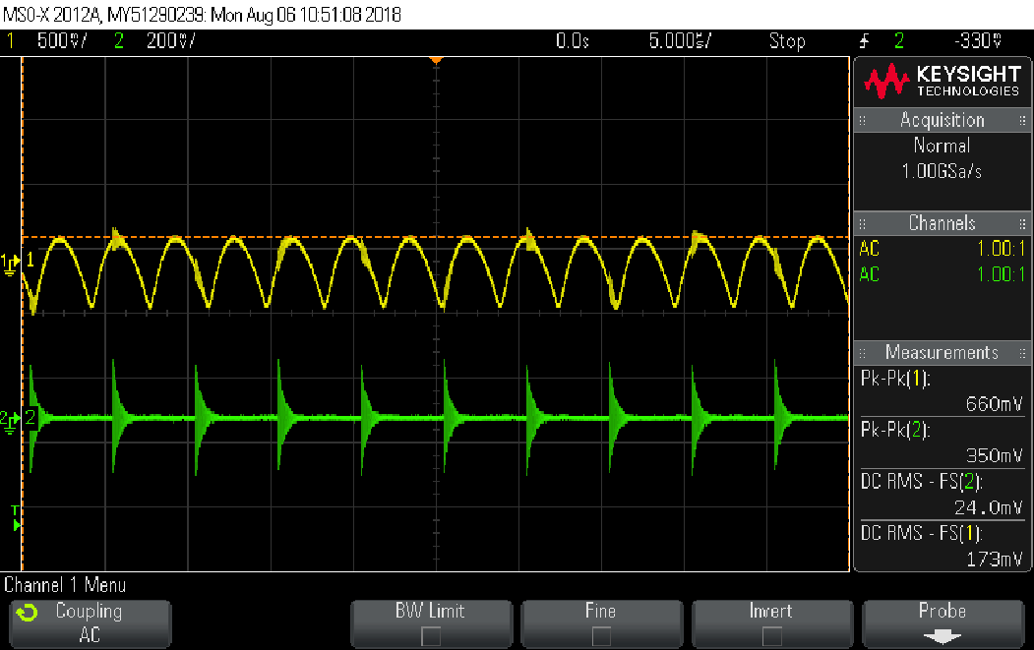

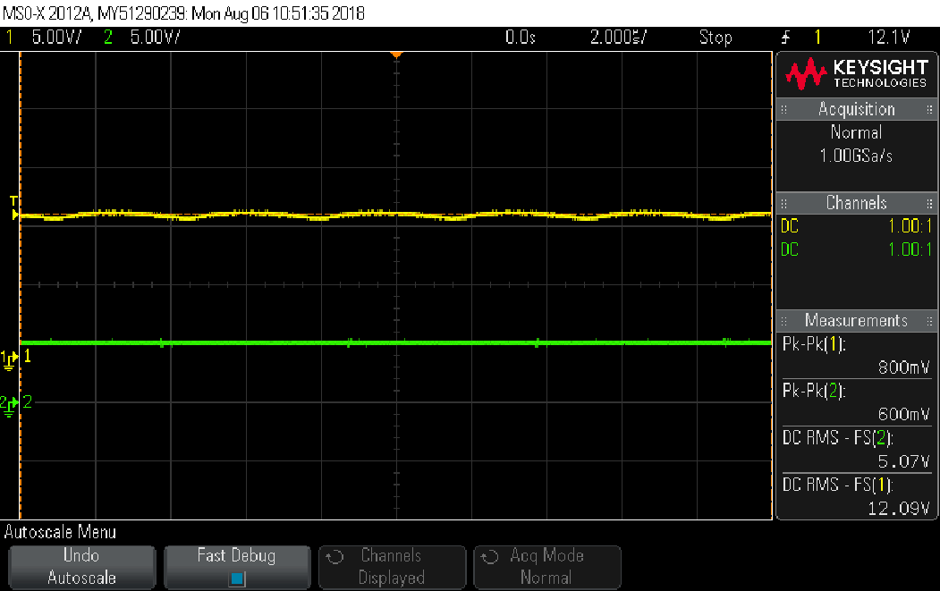

|  |
| --- |
| **Ripple factor (input):** |
| 0.66/12.63=0.0522 |
| **Ripple factor (output):** |
| 0.35/5=0.07 |

* * הפרינט הראשון מדידה בAC COUPLING והפרינט השני מדידה ב DC COUPLING
  1. Now use Ramp/100kHz/2.5VPP/0.35DC/50% symmetry to modulate the switched load, and repeat the previous section. You may assume that the average current through the switched load is the same as in the previous section; the only difference is the shape of the modulating signal. Try to think and explain why is there a difference in the results (in very few cases, there won’t be any difference).

*Print: the integral regulator’s input and output*

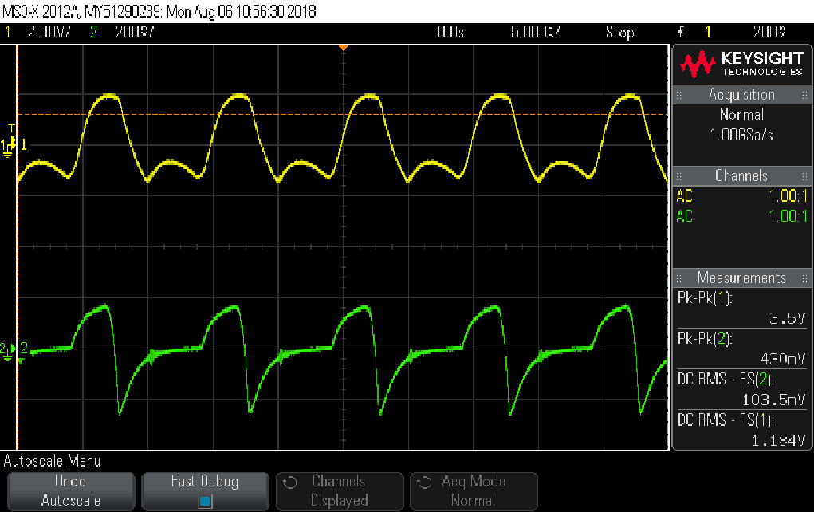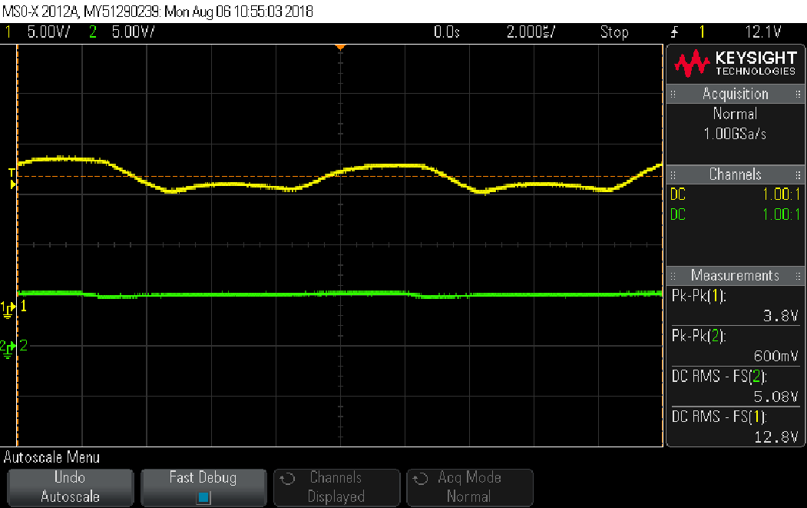

|  |
| --- |
| **Ripple factor (input):** |
| 3.5/12.8=0.273 |
| **Ripple factor (output):** |
| 0.43/5.08=0.084 |

*Ripple rejection measurement:*

* 1. Disconnect the switched load, and replace it with a 200Ω resistor.
  2. Induce a large ripple by adding an RC-link (see preliminary report, section ‎7.12) between the discrete power supply’s output and the integrated regulator’s input. Use the values from the preliminary report for the ripple. Your circuit should now look like this:

INTEGRATED

REGULATOR

DISCRETE

POWER SUPPLY

INTEGRATED POWER SUPPLY

0

RL

200

0

0V

Vripple

Figure 26

* Tip: ripple isn’t necessarily sinusoidal.
  1. Measure the input (CH1) and output (CH2) of the integrated regulator correctly to calculate the ripple rejection. Attach a print with VPP and frequency measurements (total of 4 measurements). Calculate the ripple rejection.

*Print: the integral regulator’s input and output*

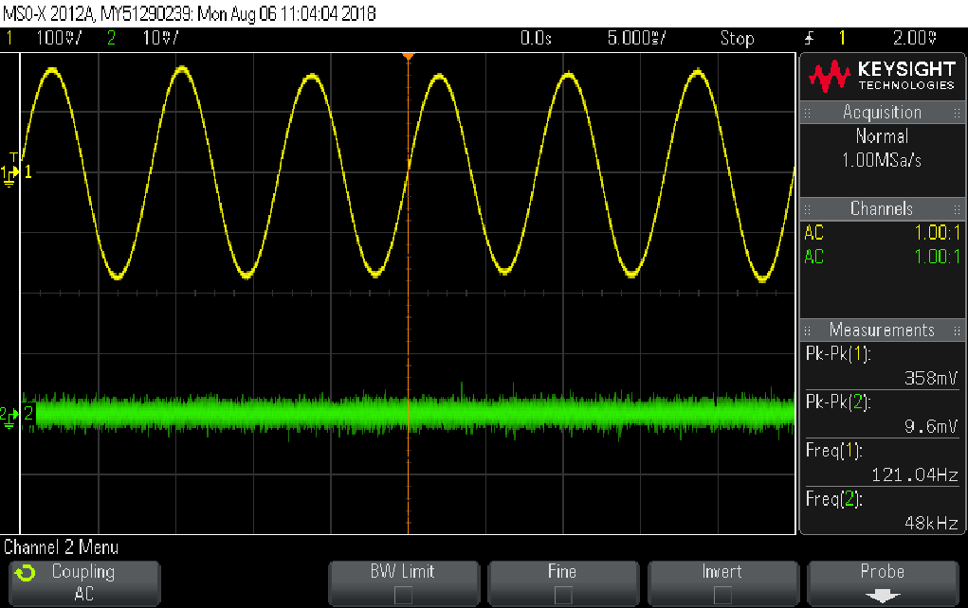

|  |
| --- |
| **Ripple rejection:** |
| 20*log(Ripplein/Rippleout)=31.4dB |

* 1. Disconnect the RC link and the load resistor.
  2. Make sure the transformer is OFF.

Applications implemented with the MC7805

Application #1: High Current Voltage Regulator

* 1. Build the circuit from the preliminary report, section ‎7.15. Use RL=100Ω.
  2. Use the multimeter to measure the discrete power supply’s output.
  3. Use the scope to measure the integral regulator’s input (CH1) and output (CH2).
  4. Write down the above measurements for four load resistors in the table below:

|  |  |  |  |
| --- | --- | --- | --- |
| (Integral regulator’s output) | (Integral regulator’s input) | Load  RL | (discrete power supply) |
| 5.1 | 11.56 | 200Ω | 12.06 |
| 5.1 | 11.33 | 100Ω | 12.05 |
| 5.1 | 11.11 | 51Ω | 12.04 |
| 5.1 | 11.05 | 33Ω | 12.03 |

* 1. Turn the transformer off. Use the preliminary report, section ‎7.15, and calculate the following, including Ry (show it is equal to one of the following: 8.2Ω, 7.5Ω, 6.2Ω):
* Hint: you can calculate some rows only after calculating others. Review the preliminary report!

|  |  |  |  |  |  |  |  |
| --- | --- | --- | --- | --- | --- | --- | --- |
| Iout 7805 | IC2 | Iin 7805 | IL | Q2’s operating region | IRy |  | Load  RL |
| 0.0255 | 0 | 0.0305 | 0.0255 | Cutoff | 0.0305 |  | 200Ω |
| 0.051 | 0 | 0.056 | 0.051 | Cutoff | 0.056 |  | 100Ω |
| 0.144 | 0.044 | 0.105 | 0.1 | Conduct | 0.061 |  | 51Ω |
| 0.248 | 0.094 | 0.159 | 0.154 | Conduct | 0.065 |  | 33Ω |

|  |  |
| --- | --- |
|  | Ry |
| Calculation | 14.42ohm |
| Nearest value | 8.2ohm |

Application #2: Adjustable Output Regulator

* 1. Disconnect everything from the circuit board **and** the AC transformer.
  2. Identify the multi-output DC power supply circuit from the preliminary report, section ‎8. While the transformer is off, make the correct connections to the transformer. Check that the transformer is wired as is in the next figure, **then call the lab instructor for his/her approval, and ASK HIM/HER TO TURN THE TRANSFORMER ON FOR YOU**:

0 "14V"

"14V" 0 "14V"

**X**

**X**

**X**

**TP33**

**TP34**

**CALL INSTRUCTOR BEFORE POWERING ON!**

0 "14V"

Figure 27

*Do not be mistaken; TP37 is already connected to the ground -**do not connect anything to TP37.**

* 1. Use the multimeter to measure the voltages for the three DC outputs and the ground terminal. Compare your results to those from the preliminary report.

|  |  |  |  |  |
| --- | --- | --- | --- | --- |
| VTP35 | VTP36 | VTP37 | VTP38 |  |
| 37.5 | 22.8 | 0.0004 | -2.3 | Measurement |
| 34 | 22 | 0 | -2 | Preliminary |

* 1. **Turn the transformer off.**
  2. Finish the remaining connections from the preliminary report, attaching the MC7805 and the op-amp for adjustable output (see section ‎7.16). **Do not connect anything to TP37. You were not supposed to change the transformer connections to the board; if you have, start again from ‎4.18.**
  3. Use the scope to measure the input of the integral regulator (CH1) and the output (CH2). Turn the transformer on and attach two prints: one showing the maximal and one showing the minimal output voltage. Add DC measurements to each signal (total of 2 measurements per print). Fill in the following table:

|  |  |  |
| --- | --- | --- |
| Load current  IL | (integral regulator’s output) | (integral regulator’s input) |
| 0.012A | Vomin=7.87 | 34V |
| 0.056A | Vomax=34.9 | 34V |

*Print: adjustable integral regulator input and minimal output*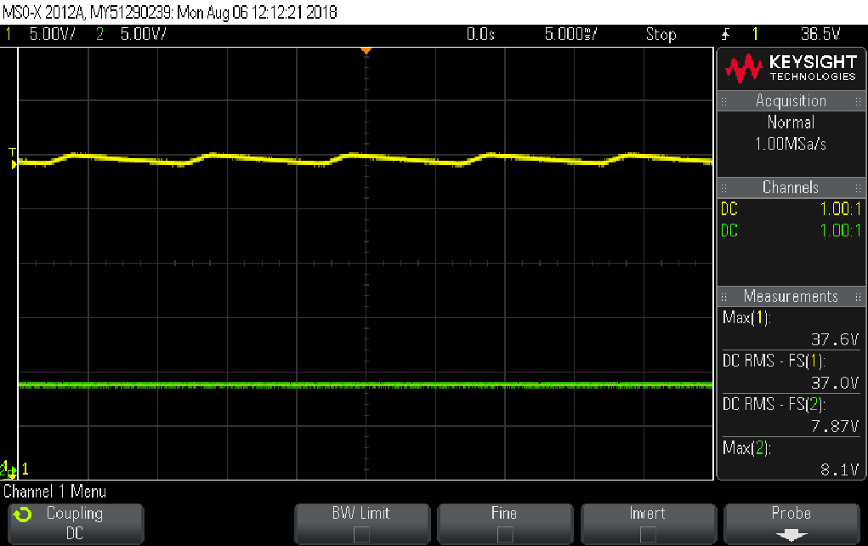

*Print: adjustable integral regulator input and maximal output*

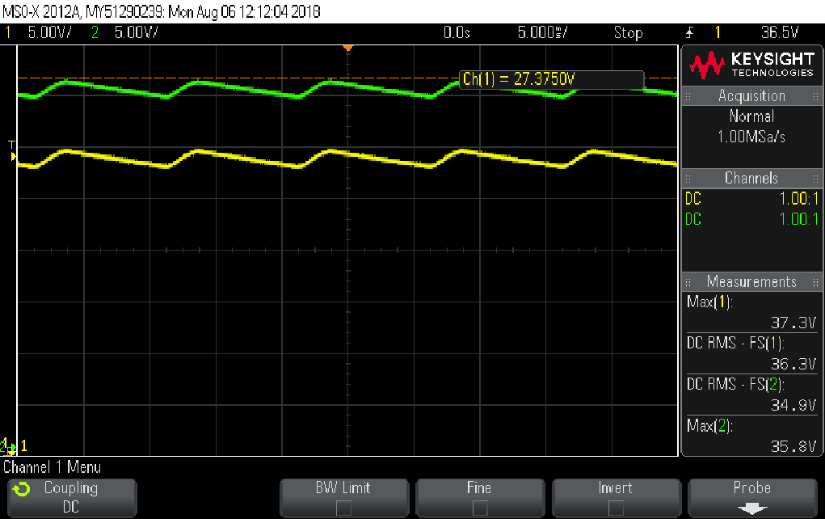

* 1. Check the result for the maximal output. Is this what you expected? Explain.

|  |  |
| --- | --- |
| ראשית, אות המוצא המקסימלי גבוה מאות הכניסה מעט. תוצאה זו הגיונית בעקבות ההגבר של מגבר השרת. |  |
| שנית, בגלל שישנו משוב חיובי במעגל (חיבור 3 מMC7508 לחיבור הנגדים ולהדק ה+ של מגבר השרת), אנו מקבלים במוצא מתח הגבוה מ5V. |  |

**This concludes experiment #3.**

**You have reached to end of this experiment: ask the lab guide to write down the time.**

**Hand in the preliminary report, and present the complete preliminary report of the next experiment before starting it.**